Lab # 10- Mechanical Waves

You should run the simulation, answer the following questions (Answer them In blue) and re-load the file (in word format) before due date.

Lab Objectives:
1- Learn about mechanical waves.
2- Study the relations between wave length frequency and speed of wave propagation.

Introduction:
A wave is a disturbance that moves through a medium or through space carrying energy and momentum. Waves are classified according to type of energy into mechanical waves, that carries mechanical energy, and electromagnetic waves that carries electric and magnetic energies.
Mechanical waves require
  - Some source of disturbance.
  - A medium that can be disturbed.
  - Some physical connection or mechanism though which adjacent portions of the medium influence each other
A pulse is a non-repeated disturbance that carries energy through a medium or through space. If the pulse is repeated periodically, then a series of crests and troughs will travel through a medium creating a travelling wave.
A transverse wave is a disturbance in a medium in which the motion of the motion of the particles is perpendicular to the direction of the wave motion (e.g. waves in a string). A longitudinal wave is a disturbance in a medium in which the motion of the particle is along the direction of the wave travel. For example, Sound.
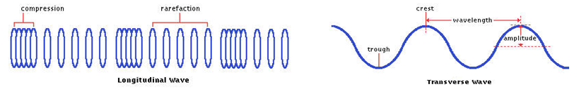
Mathematical Description of a wave:
A waveform can be represented by a sine functions in space (x) and time (t) as follow:

y(x,t)=Asin(kx-ωt) = Asin(kx-2πft)

where y(x,t) is the wave displacement at a given point defined by its position ,x, at a time ,t. A is Amplitude, k is the wave number, ω is angular frequency and f is frequency.
ω=2π/T, k=2π/λ, T=1/f, wave speed (v) = λ/T = λf
The quantities describing a wave are summarized as:
- Amplitude (A) of a wave is the maximum displacement of any part of the wave from its equilibrium or rest position.
- Wavelength (λ) is the measured distance for one complete cycle of the wave.
- Period (T) is the time required for a single wave to pass a given point.
- Frequency (f) is the number of complete waves passing a given point per unit time.
Waves in a string is an example of transverse mechanical wave. A vibrating string, such as a guitar or piano string also produces a sound whose frequency in most cases is constant.
The speed of propagation of a wave in a string (v) is proportional to the square root of the tension of the string (F_{T}) and inversely proportional to the square root of the linear mass density (μ) of the string: $v=\sqrt{\frac{F_{T}}{}}$

Standing waves on a string: ${}_{n}=\frac{2L}{n}$ $f_{n}=\frac{v}{{}_{n}}=n\frac{v}{2L}$ $f_{n}=\frac{n}{2L}\sqrt{\frac{F_{T}}{}}$
The index n on the wavelength (or frequency) indicates the harmonic. That is, n=1 identifies the first harmonic (also called the fundamental frequency), n=2labels the second harmonic, and so on.

Simulation:
Open Waves
http://phet.colorado.edu/en/simulation/wave-on-a-string
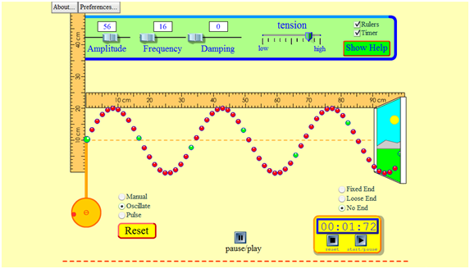

Procedure:
- Apply the following settings to the simulation: Set Wave to Oscillate, End type to No End, Amplitude to 0.6 cm, Frequency to 2 Hz, Damping to 0, and Tension to High. Make sure to check the Rulers and Timer boxes. [ Note: Max Amplitude= 3.0 cm and Max Freq.=3 Hz available in simulation Software]
  - Run the simulation and observe how the wave behaves.
  - Click the pause/play button to stop the simulation.
  - Measure the wavelength. Wavelength (λ) = ___3.1___ cm
  - Measure the amplitude. It is measured from the middle reference line to a crest (or a trough). You can drag the reference line to the position of a crest or a trough then measure between these reference lines. Amplitude (A) = ___0.3___ cm
  - With the simulation paused, reset the timer and use the step button to determine the period of the wave. Make sure to step the time from a crest to the next crest. This can easily be one using the ruler as a reference.
Period (T) = ____ s
  - Calculate the frequency. Frequency (f) = ____ Hz
  - Calculate the speed of the wave. Speed (v) = ____ m/s
  - Assuming the “High” position of the tension as 1N, calculate the linear mass density (μ) of the string. μ = ____ kg/m
  - Using the information of the wavelength you found, calculate the original length of the string. Length (L) = _____ m
- Apply the following settings to the simulation: Leave all settings the same as in step 1 except the tension to 0.9 N (remember, High is 1N).
  - Wavelength (λ) = _____ cm
  - Period (T) = _____ s
  - Speed (v) = _____m/s
  - Calculate the tension using the linear density found in step 1h. Tension (T) = _1.01__N
  - In order to recover the wavelength found in step 1c, you need to change the frequency slide bar. What will be the new position (value) of the frequency slide bar? _______

- Apply the following settings to the simulation: Leave all settings as step 1 except the Amplitude to 80.
  - Wavelength (λ) = _____ cm
  - Period (T) = _____ s
  - Speed (v) = _____m/s
  - Calculate the tension using the linear density found in step1h. Tension (T) = ___N
  - Which one of the above quantity changed?
- Can you tell about the setup used from the following graph? Describe all the settings you think applied to get this graph. The period of the wave is 1:11 sec.
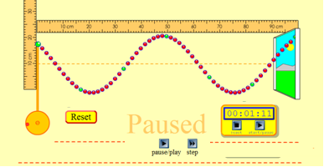
- Apply the following settings to the new simulation: Click Reset button, Set Wave to Pulse, End type to Fixed End, Amplitude to 0.9 cm , Frequency to 2, Damping to 0, and Tension to High.
  - Click the pulse button and observe the pulse moving through the string.
  - Describe what the wave does as it moves down the string. After it hits the end of the string, what happens to the wave?

- Click the Reset button. Keep the same settings as in step 5 except set End Type to Loose End
  - Click the pulse button and observe the pulse moving through the string.
  - Describe what the wave does as it moves down the string. After it hits the end of the string, what happens to the wave?

GOOD LUCK

